--------------------------------------------------------------------------

OOPM - PRACTICAL EXAM.  
YASH SARANG. D6AD / 47.

--------------------------------------------------------------------------

AIM: Write a JAVA program for class Student, accept the name, roll no., marks of three subjects, calculate total, and display the complete information.

--------------------------------------------------------------------------

Program:

Main.java

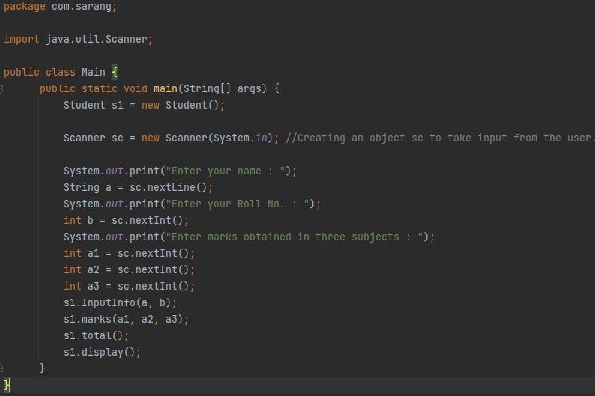

Student.java

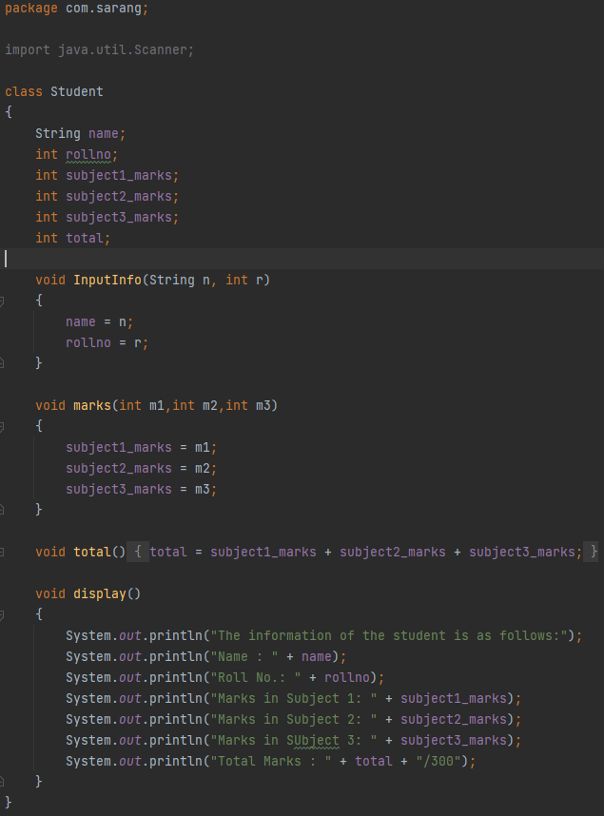

--------------------------------------------------------------------------

Theory:

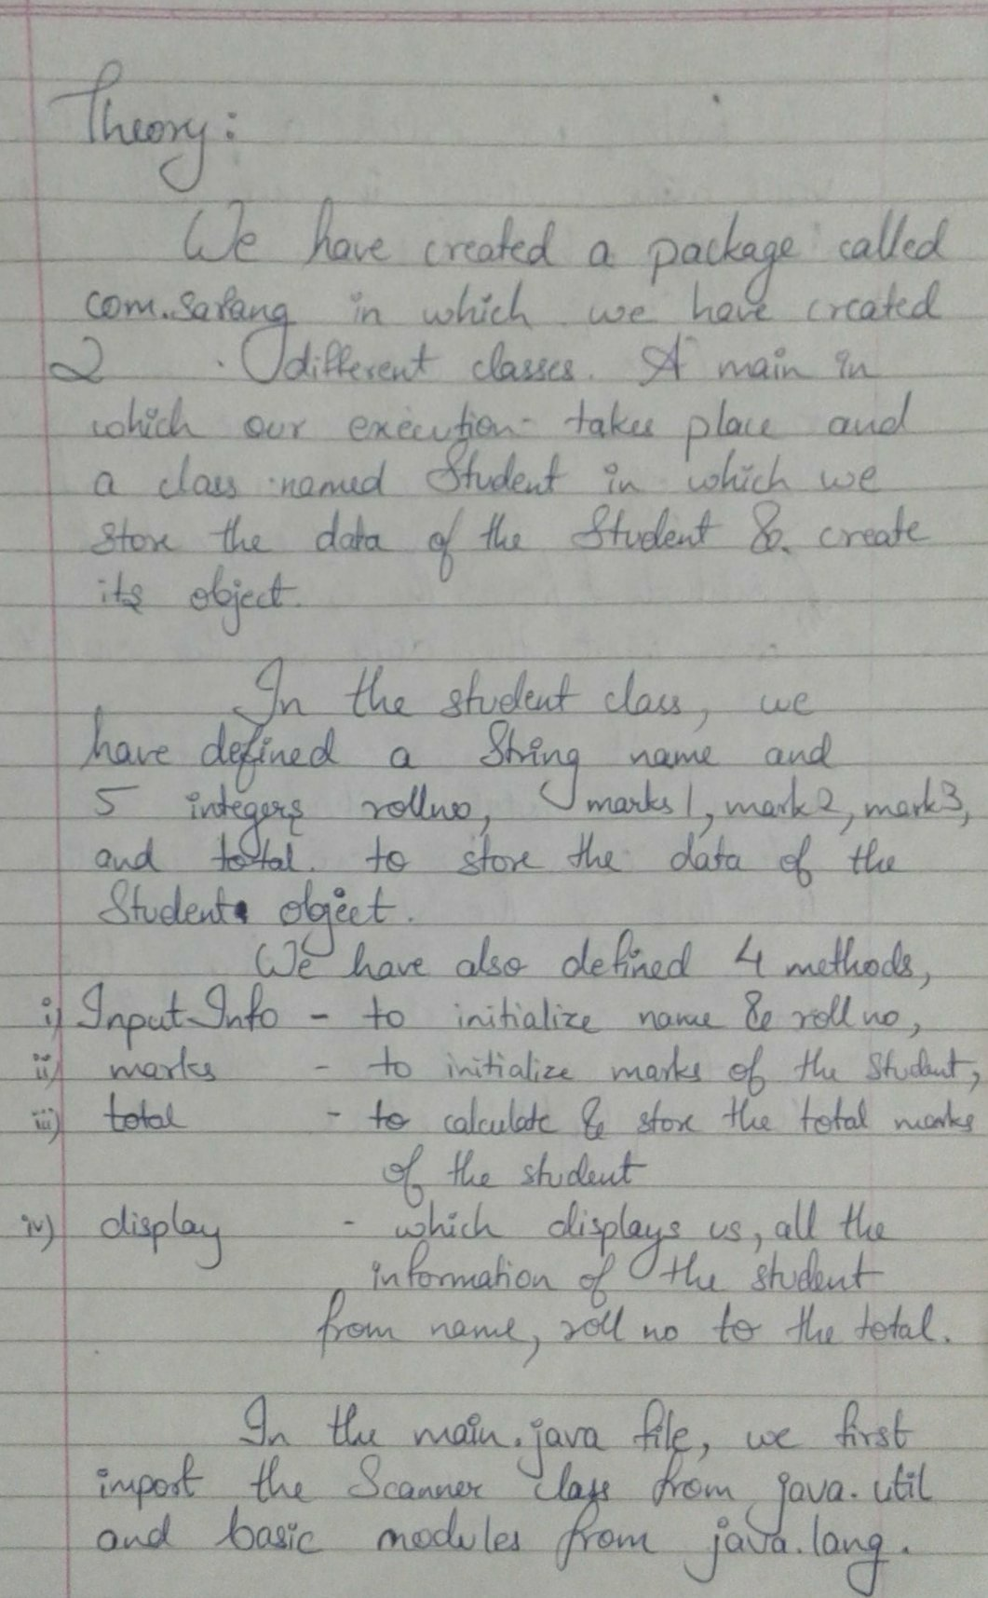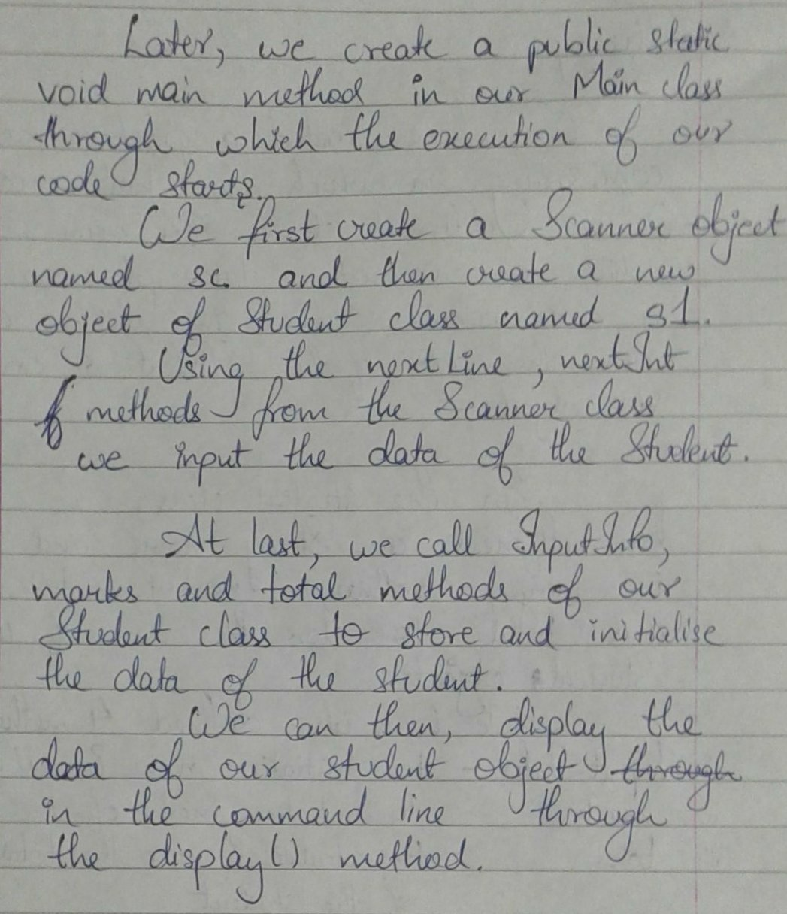

--------------------------------------------------------------------------

**OUTPUT:**



